PROGRAM REPORT
PROGRAM- INDEPENDENCE DAY
Composite Regional Centre for Skill Development, Rehabilitation and Empowerment for persons with Disabilities, Nagpur organized a program on the occasion of 75th independence day. People from all the disabilities have gathered at CRC Nagpur centre. Flag Hosting was done by the Director Mr. Prafull Shinde followed by tree plantation activity by all the staff and assistant Professor of CRC Nagpur.
Main focus of the program was to motivate and faciliate parents and Divyangjan who has achieved and are fighting hard to achieve something in life. Momentos were distributed to Visually Impaired. Divyangjan who dispite of Disability have secured high posts in Banking, have limka book of records and also have taken singing classes from famous Singer Mr. Suresh Wadkar. CRC Nagpur facilitated them for their courage and dedication.
Physically impaired Divyangjan were also awarded for singing and for their contribution as a entrepreneurs.It was a program full of music and zeal of motivation not only for parents but also for us as a professional.
Mr. Prafull Shinde assured to be supportive in every aspect to these divyagjans.
Anchoring was done by Mr. Rajendra Meshram. Mr. Mohd Aslam orientation and mobility instructor had anchored the program for visually impaired Divyangjan. All staff Mr. Jagan mudgade Dr. Vitthal puri, Kavita Ghodmare, kalyani bhagwat, Nirmal Das, Ganesh Sarode were present in the program
The program was coordinated by Dr. Ashwini Dahat Lecturer Occupational therapy CRC Nagpur.

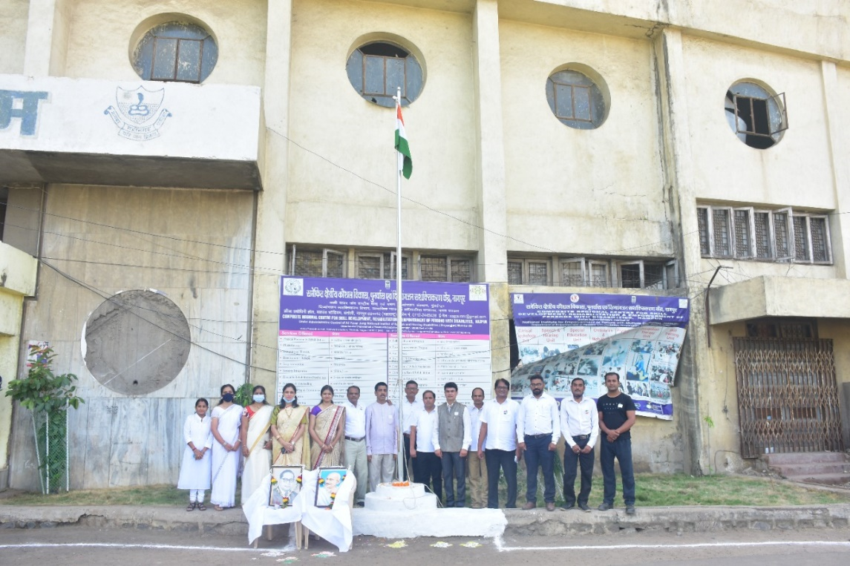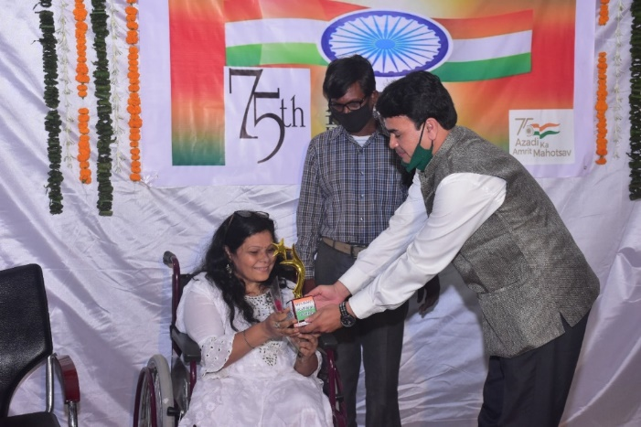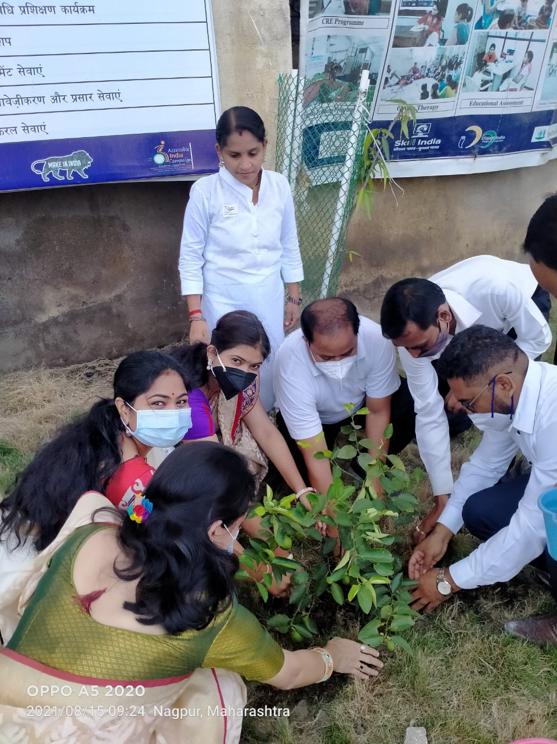

- ASHWINI DAHAT
- LECTURER OT,CRC NAGPUR.

