 | समेकित क्षेत्रीय कौशल्य विकास, पुनर्वास एव दिव्यांगजन सशक्तिकरण केंद्र, नागपूर  (सी.आर.सी - नागपूर)  (अ.या.जं.रा.वा.श्र.दि.सं.,मुंबई के प्रशासनिक नियंत्रणाधीन)  दिव्यांगजन सशक्तिकरण विभाग,  सामाजिक न्याय एवं अधिकारिता मंत्रालय, भारत सरकार  क्रीड़ा प्रबोधिनी हॉल, यशवंत स्टेडियम, धंतोली,  नागपूर-440012 . दूरभाष (0712)2445439  ई-मेल : nagpurcrc@gmail.com  वेबसाइट : www.crcnagpur.org | Composite Regional Centre For Skill Development, Rehabilitation & Empowerment of Persons with Disabilities, (Divyangjan), Nagpur.  (CRC – Nagpur)  (Under the Administrative control of AYJNISHD(D), Mumbai)  Dept. of Empowerment of Persons with Disabilities, (Divyangjan)  Ministry of Social Justice and Empowerment, Govt. of India.  Krida Prabodhini Hall, Yashwant Stadium, Dhantoli,  Nagpur-440012 (Maharashtra)  Phone (0712)2445439  Email: nagpurcrc@gmail.com  Web: www.crcnagpur.org
संदर्भ संख्या : दिनांक :
Ref. No: Date:
Dept.of Clinical psychology, CRC,Nagpur
SUCCESS STORY
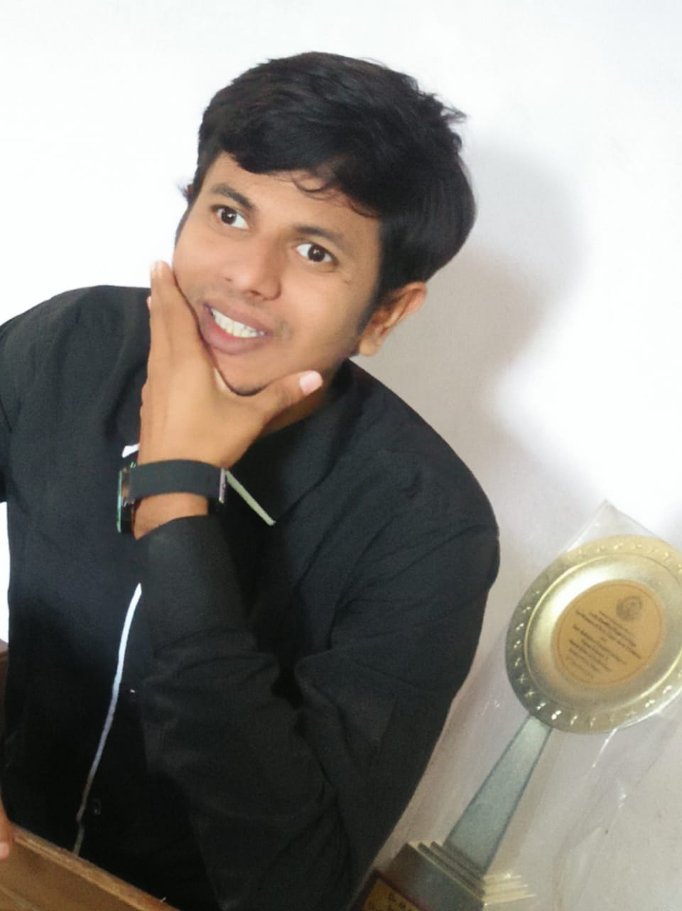
Mr. Harish Prajapati (Visually Impaired)

The human spirit is one of ability, perseverance and courage that no disability can steal away. ...

Dept.of Clinical psychology, CRC,Nagpur has been taken an initiative to promote person with disability through the special event of ”Youth talent Festival for PwD” by giving an opportunity to Mr. Harish Prajapati (Visually Impaired) for anchoring in the programme
His name is Harish Mahavir Prajapati, He was born in a lower middle class family and his father is an e-rickshaw driver, He lost his vision at the age of three and got his education up to 10th standard from Gyanjyoti Blind School Nagpur, 11th to till now he have been doing his education from Vasantrao Naik Government Institute of Art and social Science college Nagpur.
He is a Debater, a Rhetorician, a National chess player, a poet, a Comedian, a Motivational speaker, a Mimicry Artist and has participated in numerous competitions and won more than 100 awards.
His college has given him award of Mr. Institute. According to Rotary Club of Kolhapur, Savi Foundation of Pune, they have given him award of India's best speaker in English. He is also a YouTuber.
He have written a book, named "HUM TO JITENGE" .The main goal of the book is to develop confidence among person’s with disabilities. He wants to be a motivational speaker. He choose his passion as an career the rather than the job in disability quota because according to him,” Disability is a matter of perception”.
He topped in geography subject in 12th, and done B.A. with psychology subject despite his condition of disability.
His honest opinion is that perseverance, constantly, hard work is the only way to achieve any goal. “The only thing worse than being blind is having sight but no vision. ...”.

Aparna D.Bhalerao
Assistant Professor, Clinical Psychology,
CRC,Nagpur

